Name: Ananya Barui
Phone: +91-9733388223

Email ID (Institutional):ananya.barui@chest.iiests.ac.in
Email ID (Others, Optional):ananya.pariksha@gmail.com

Resume:
- PhD (IIT, Kharagpur)
- M. E. (Jadavpur University)
- B. Tech (Allahabad)
Experience:
  - BIT Mesra
  - IIEST Shibpur

ORCID: https://orcid.org/0000-0001-9710-9448

SCOPUS: 36621769700

Google Scholar: https://scholar.google.com/citations?user=DRBjqtoAAAAJ&hl=en&authuser=1

Vidwan: 105346

Lab: M. Tech Biomedical Engineering: Imaging and stem cell research

Activity: Microscopy for cancer and stem cell imaging and early diagnostics.

Images:
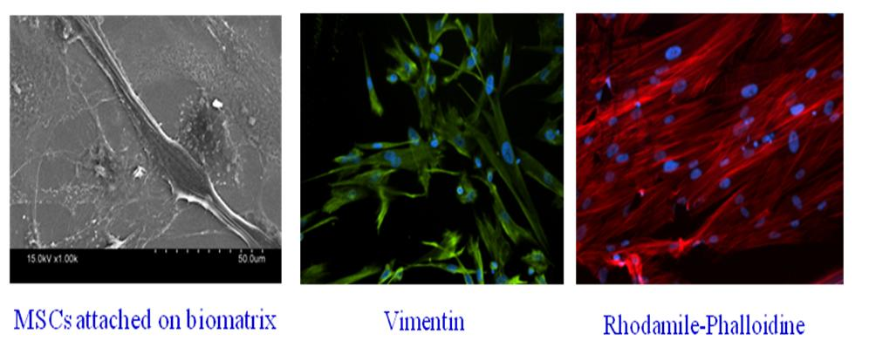

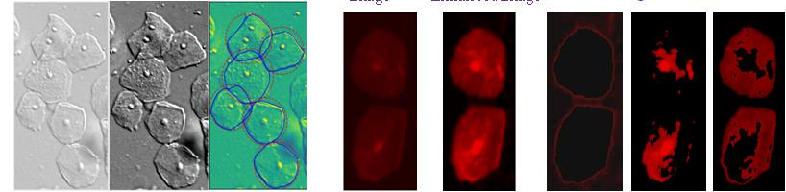
Bio-Markers identified for cancer diagnosis

